

ITRW 225

Group Report 1

Morné du Plooy 25107615

Gerrie du Plessis 27234282

Contents

1. Project plan in Ms Project 3

2. Feasibility Analysis Matrix 4

3. Physical Data Model 5

4. Physical Process Model 6

5. Network Architecture DFD 7

6. Prototypes of input, output and user interface 8

Login form 8

Home Screen 8

Add Clothes 9

Add User or Client 9

7. Database schema in MS Access 10

8. Example code 11

9. Example report 15

# 1. Project plan in Ms Project

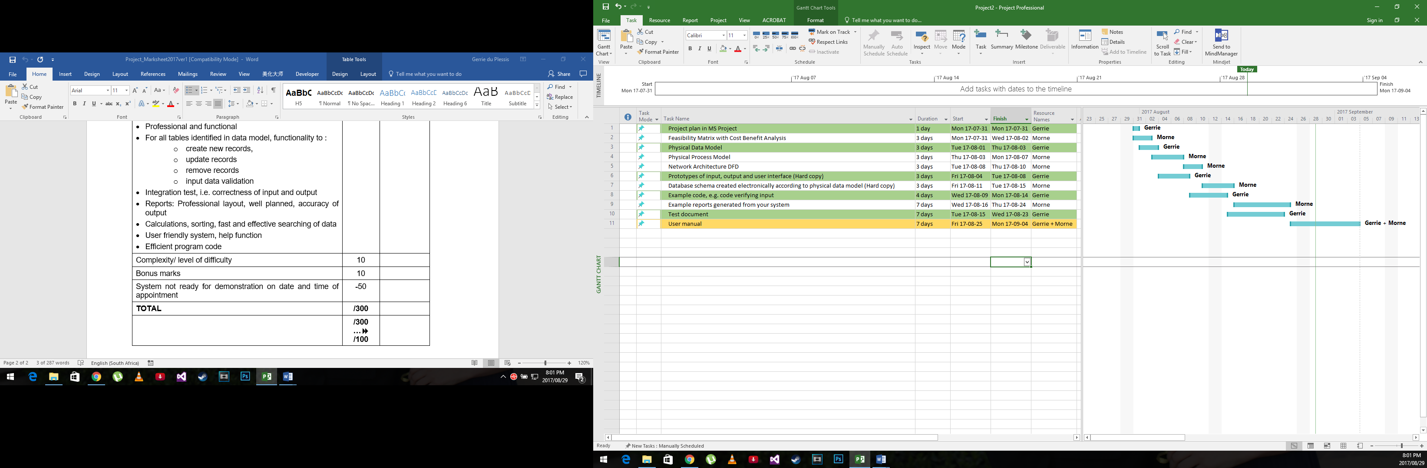

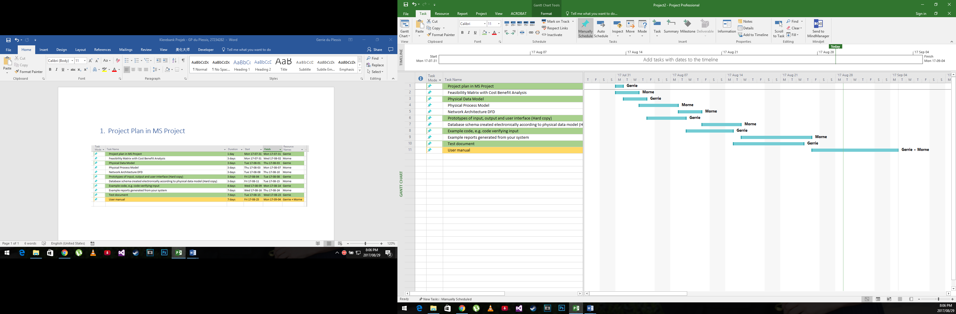

# 2. Feasibility Analysis Matrix

|  |  |  |  |  |
| --- | --- | --- | --- | --- |
|  | Weight | Candidate1 | Candidate2 | Candidate3 |
| Description |  | Buy commercial off the shelf program and install it on current system | Modify the current software for better efficiency | Develop a new system |
| Operational feasibility | 25% | Not completely customizable and there is going to be a learning curve for the users to master the program  Score: 70 | Will make the system more reliable and the users are already familiar with the system  Score : 80 | Will provide a completely customised program that will with time be the most efficient  Score : 90 |
| Technical feasibility | 25% | System requirements must be met for commercial software so a possible hardware upgrade is needed as well training for the users  Score : 50 | To modify the current system will take a long time because the programmers will need to learn the old system first  Score : 70 | New software will be quick to develop with proper guidelines  Score : 90 |
| Economic feasibility ** | 30% | The cost of buying a new system is going to be very expensive and will be upwards of R120000 for everything, for a non-profit organization is very expensive  Score : 5 | This solution would not cost a lot but because of the time needed with the current system the cost of living for system implementers would cost a lot  Score : 60 | Because of the quick and easy nature of this solution the costs would be the lowest  Score : 100 |
| Schedule feasibility | 10% | Less than a week  Score : 100 | 6 – 12 months  Score : 50 | 1-3 months  Score : 90 |
| Legal feasibility | 10% | No foreseeable problems  Score : 100 | No foreseeable problems  Score : 100 | No foreseeable problems  Score : 100 |
| Weighted score | 100% | 51.5 | 90.5 | 94 |

** Our company is a non-profit church organization that’s why we didn’t include the cost benefit analysis

# 3. Physical Data Model

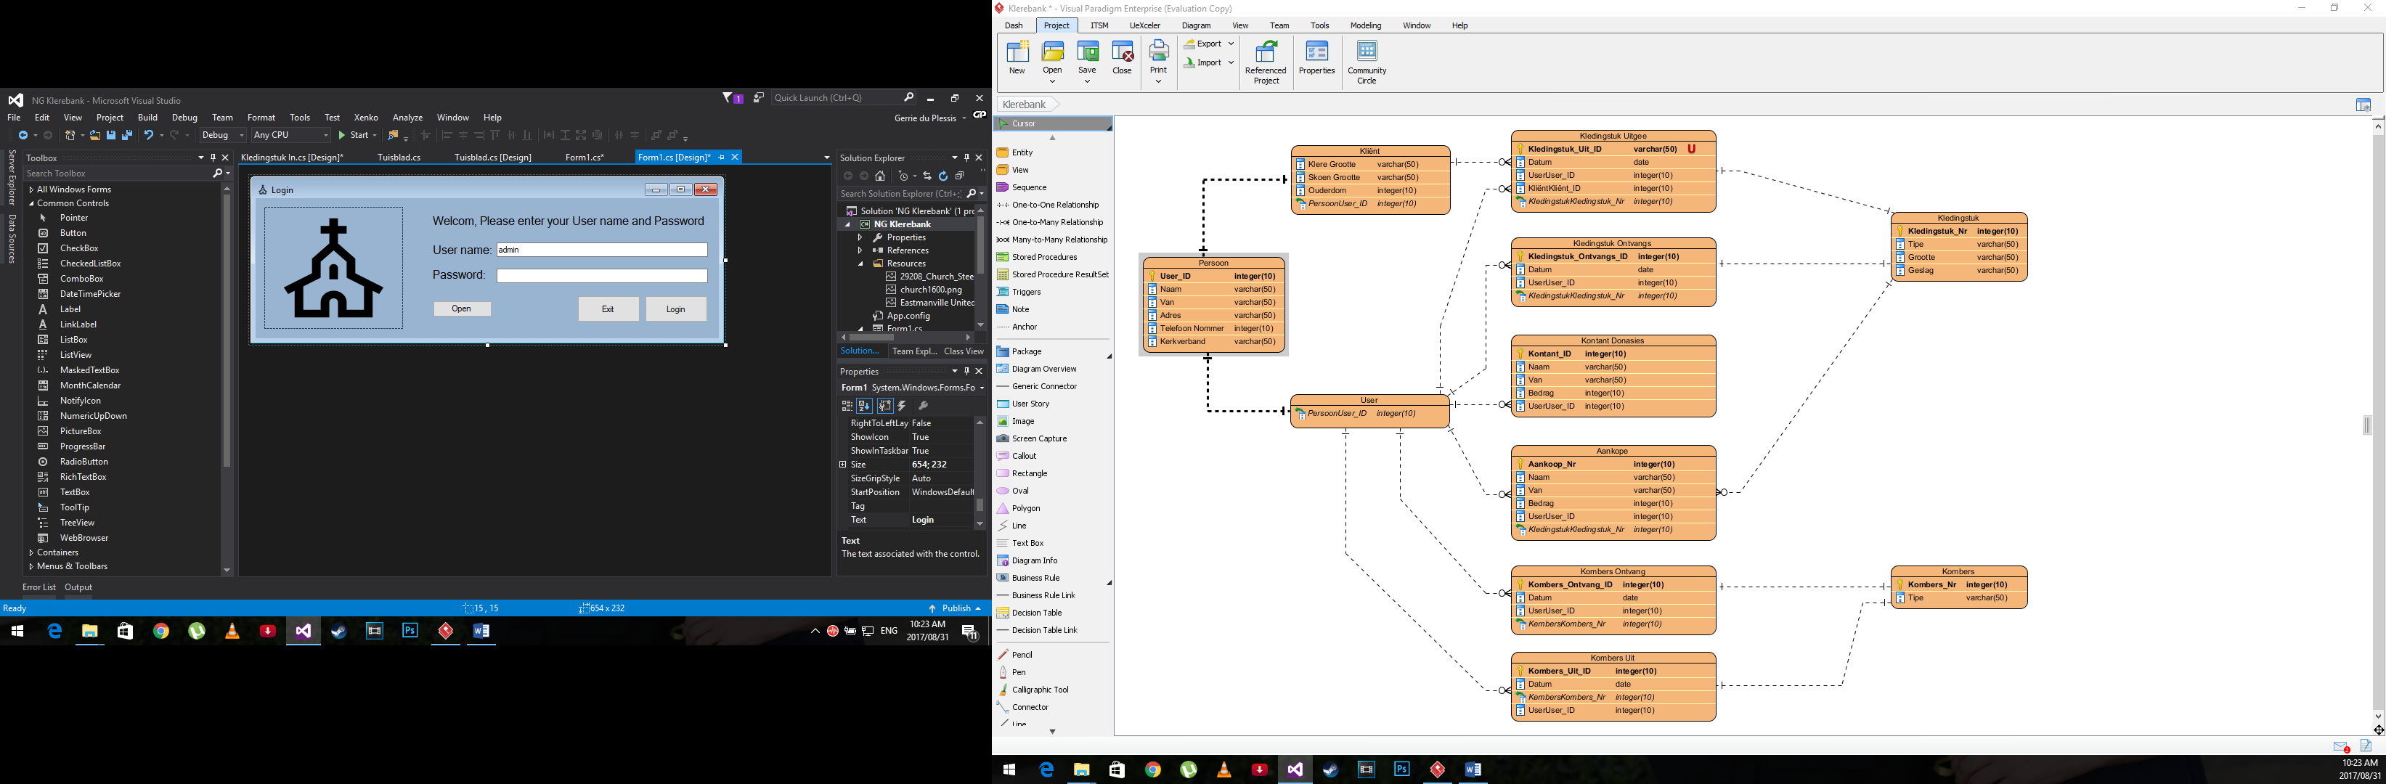

# 4. Physical Process Model

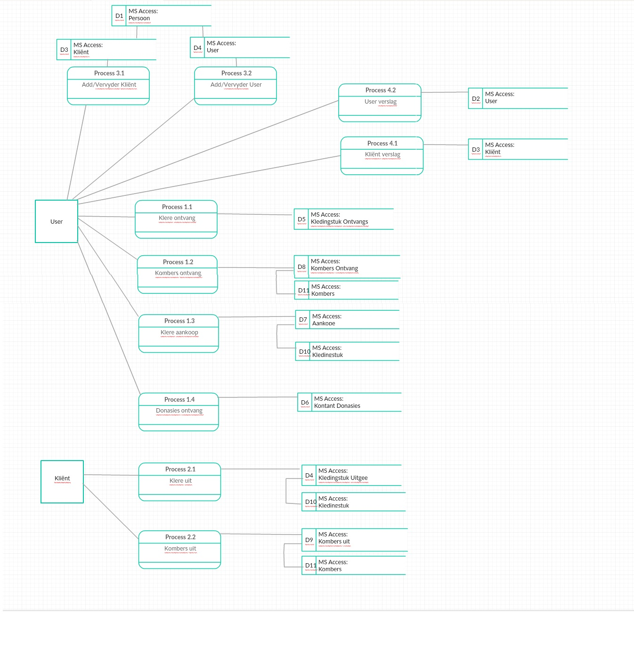

# 5. Network Architecture DFD

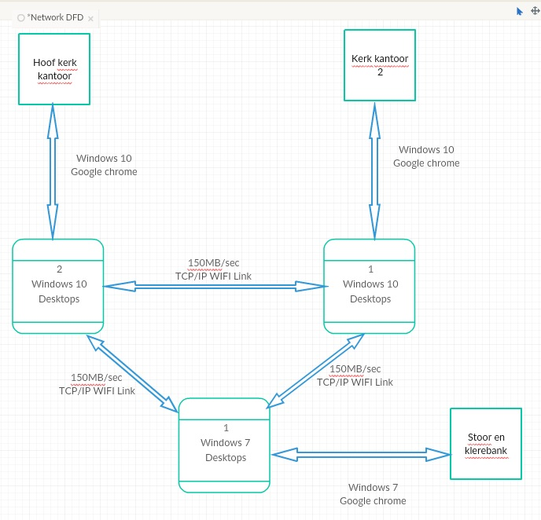

# 6. Prototypes of input, output and user interface

### Login form

### Home Screen

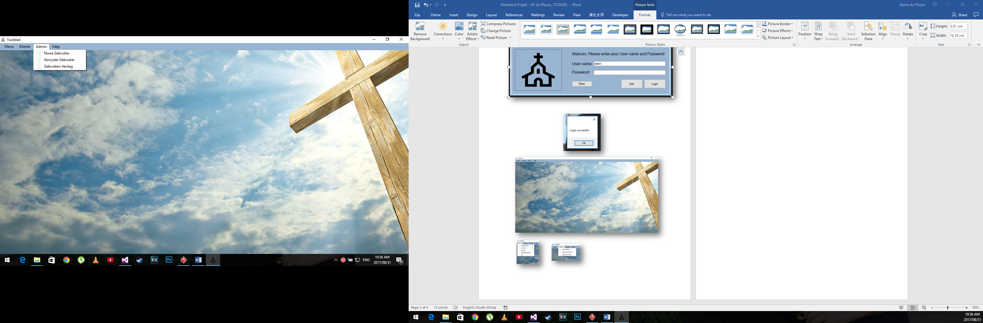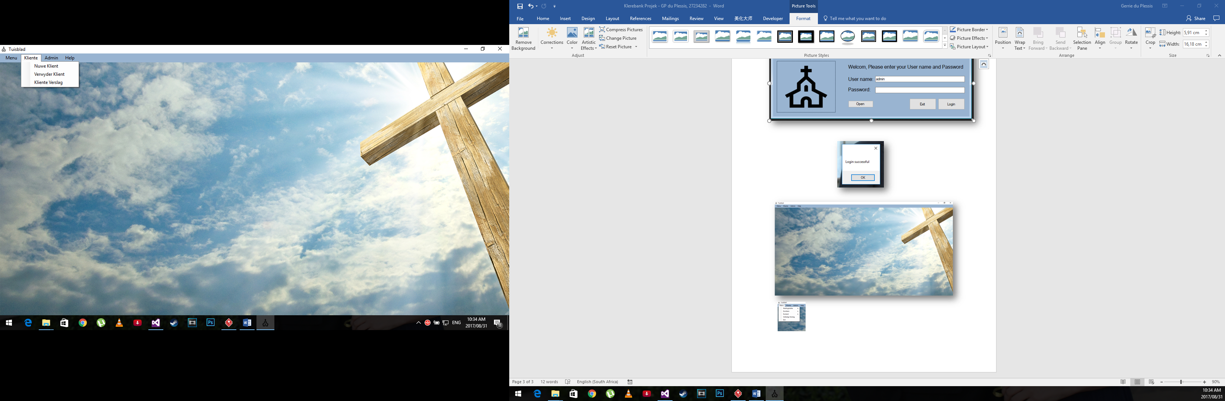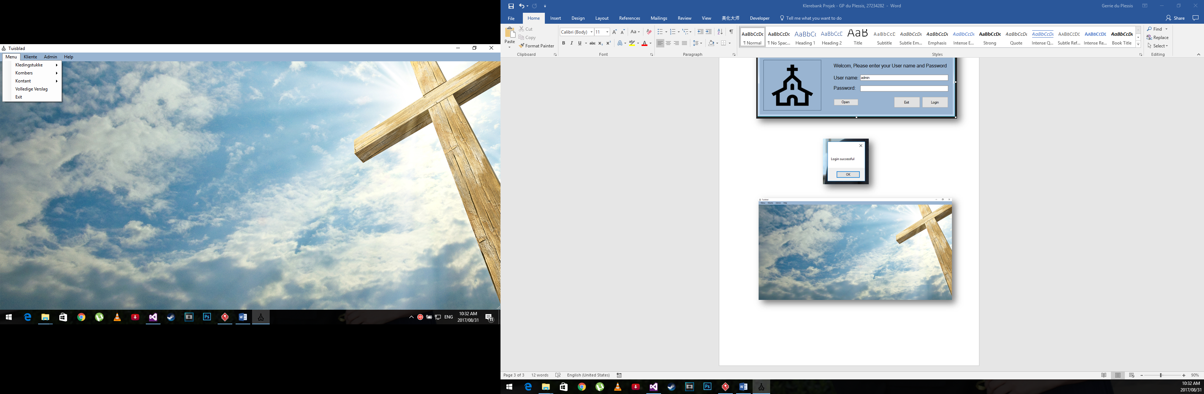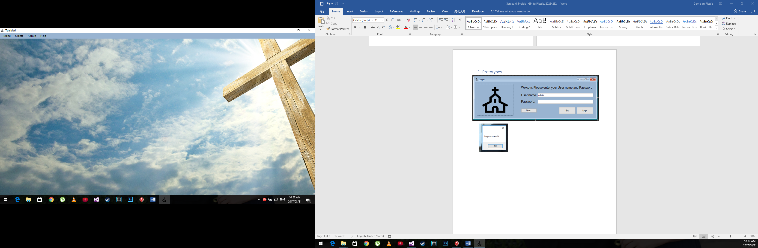

### Add Clothes

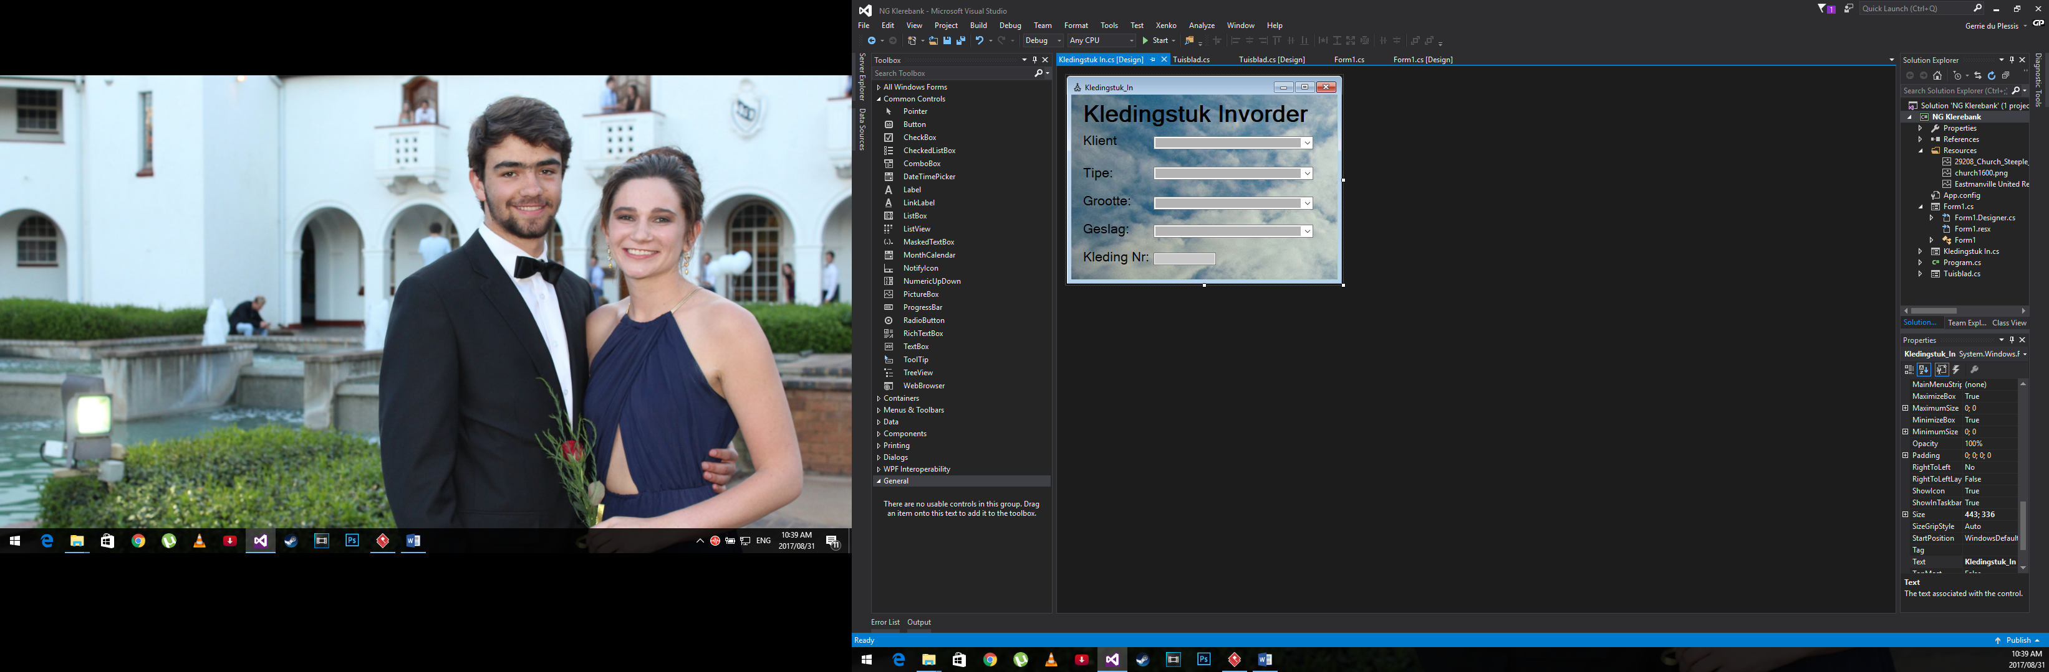

### Add User or Client

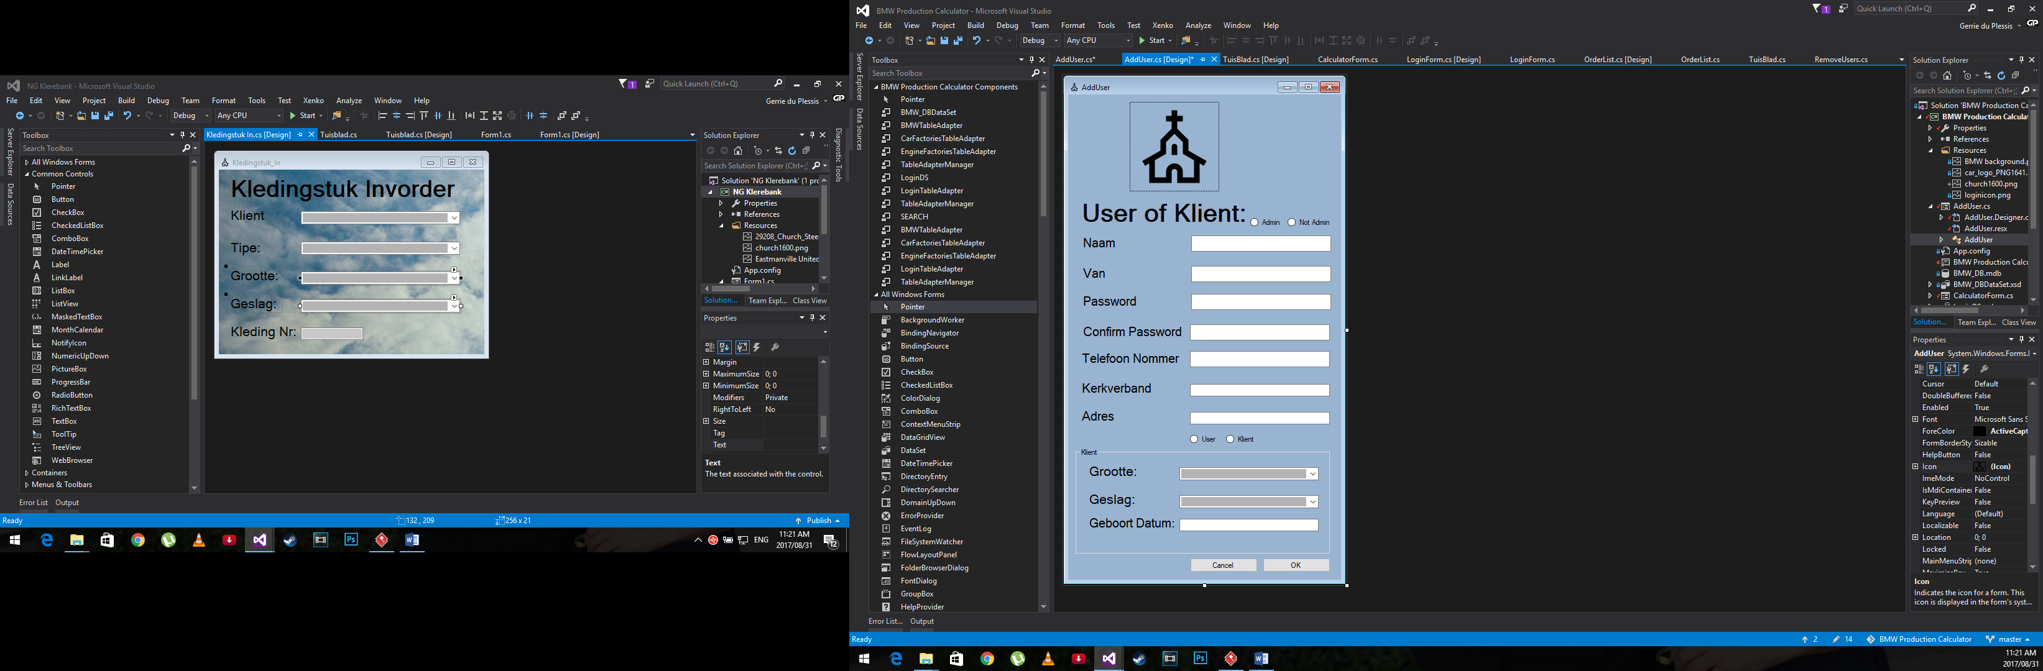

# 7. Database schema in MS Access

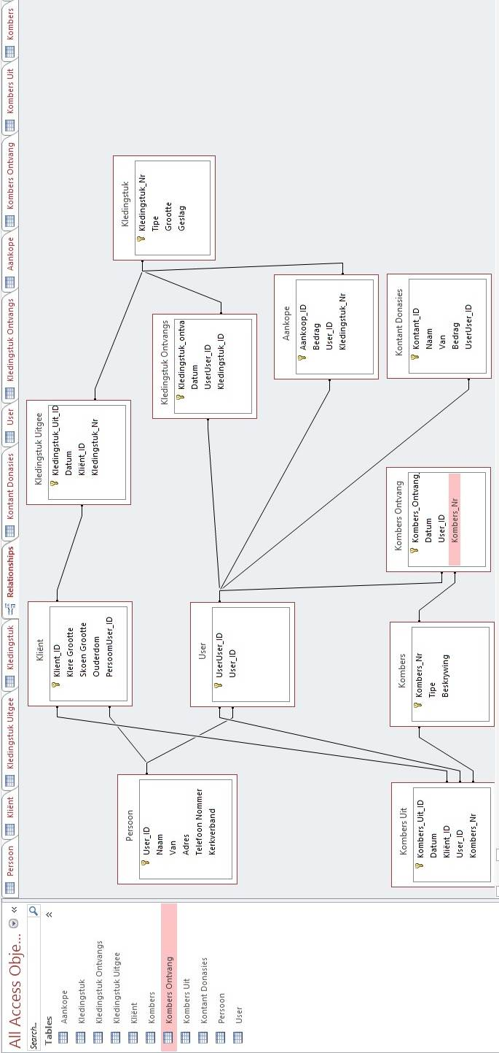

# 8. Example code

**Login**

1. using System;
2. using System.Collections.Generic;
3. using System.ComponentModel;
4. using System.Data;
5. using System.Drawing;
6. using System.Linq;
7. using System.Text;
8. using System.Threading.Tasks;
9. using System.Windows.Forms;
10. using System.Data.OleDb;
11. namespace NG_Klerebank
12. {
13. public partial class Form1 : Form
14. {
15. public static string spath;
16. public Form1()
17. {
18. InitializeComponent();
19. txtPassword.PasswordChar = '*';
20. }
21. private void btnLogin_Click(object sender, EventArgs e)
22. {
23. if (txtUserName.Text != "" || txtPassword.Text != "")
24. {
25. string name = txtUserName.Text;
26. string pass = txtPassword.Text;
27. if (name != "" && pass != "")
28. {
29. OleDbConnection conn = new OleDbConnection(@"Provider=Microsoft.Jet.OLEDB.4.0;Data Source= " + Form1.spath);
30. conn.Open();
31. OleDbDataAdapter adap = new OleDbDataAdapter("select * from Login where Username='" + name + "' and Password='" + pass + "'", conn);
32. DataTable dt = new DataTable();
33. adap.Fill(dt);
34. if (dt.Rows.Count == 1)
35. {
36. MessageBox.Show("Login successful");
37. this.Hide();
38. Tuisblad tuisB = new Tuisblad();
39. tuisB.ShowDialog();
40. this.Close();
41. }
42. else
43. {
44. MessageBox.Show("User name or Password is invalid.");
45. }
46. }
47. else
48. {
49. MessageBox.Show("User name or Password is invalid.");
50. }
51. }
52. }
53. private void btnExit_Click(object sender, EventArgs e)
54. {
55. this.Close();
56. }
57. private void btnOpen_Click(object sender, EventArgs e)
58. {
59. btnLogin.Visible = true;
60. btnExit.Visible = true;
61. calculatePath();
62. }
63. public void calculatePath()
64. {
65. do
66. {
67. OpenFileDialog opf = new OpenFileDialog();
68. if (opf.ShowDialog() == DialogResult.OK)
69. {
70. spath = opf.FileName;
71. }
72. else
73. {
74. MessageBox.Show("ERROR");
75. }
76. }
77. while (spath == "");
78. }
79. }
80. }

**Add User**

using System;

using System.Collections.Generic;

using System.ComponentModel;

using System.Data;

using System.Drawing;

using System.Linq;

using System.Text;

using System.Threading.Tasks;

using System.Windows.Forms;

using System.Data.OleDb;

namespace BMW_Production_Calculator

{

public partial class AddUser : Form

{

OleDbConnection conn = new OleDbConnection(@"Provider=Microsoft.Jet.OLEDB.4.0;Data Source= " + Form1.spath);

public string naam;

public string pass;

public string pass2;

public int admin = 0;

public string van;

public string tel;

public string kerk;

public string adres;

public string grootte;

public string geslag;

public string geboorte;

public AddUser()

{

InitializeComponent();

txtVan.PasswordChar = '*';

txtTel.PasswordChar = '*';

}

private void btnAdd_Click(object sender, EventArgs e)

{

naam = txtUsername.Text;

pass = txtPass.Text;

pass2 = txtPass2.Text;

van = txtVan.Text;

tel = txtTel.Text;

kerk = txtKerk.Text;

adres = txtAdres.Text;

grootte = cbGrootte.Text;

geslag = cbGeslag.Text;

geboorte = txtOuderdom.Text;

Boolean exists = false;

if (rbYes.Checked == true)

{

admin = 1;

}

else

admin = 0;

// checks to see if the username exists.

OleDbDataAdapter check = new OleDbDataAdapter(@"SELECT * FROM login WHERE username LIKE '" + naam + "'", conn);

DataTable usernameCheck = new DataTable();

check.Fill(usernameCheck);

if (usernameCheck.Rows.Count == 1)

{

MessageBox.Show("Username already exists.");

exists = true;

}

// check to see if the passwords entered are the same if the username exists or not.

// if one of the conditions are false an error message wil display.

if ((pass == pass2) && (exists == false))

{

// insert the new user into the login table of the database.

conn.Close();

conn.Open();

OleDbCommand cmd = new OleDbCommand(@"INSERT Into login(naam,[password],Admin,van,Telefoon,Kerkverband,adres,Kleding_Grootte,Geslag,Geboorte_Datum) values('" + naam + "','" + pass + "','" + admin + "'" + van + "','" + tel + "','" + kerk + "','" + adres + "','" + grootte + "','" + geslag + "','" + geboorte + "')", conn);

cmd.ExecuteNonQuery();

MessageBox.Show("The user: " + naam + " was sucsesfully added!");

this.Close();

}

else

{

if (pass != pass2)

{

MessageBox.Show("The passwords is not the same.");

}

else

{

MessageBox.Show("Username already exists.");

}

}

/*string wagwoord = txtP1.Text;

int admin = 1;

string naam = txtUsername.Text;

OleDbDataAdapter adapter = new OleDbDataAdapter(@"SELECT * FROM DVD", conn);

OleDbCommand cmd = new OleDbCommand(@"INSERT Into login(Username, [Password], Admin) values('" + naam + "','" + wagwoord + "','" + admin + "')", conn);

cmd.ExecuteNonQuery();

MessageBox.Show("User has beem succesfully added");*/

}

private void AddUser_Load(object sender, EventArgs e)

{

conn.Open();

}

}

}

# 9. Example report